Portal Functional Scope Document

Submitted to:
Jorge Basto, CIO
Judicial Council / Administrative Office of the Courts
244 Washington Street, Suite 300
Atlanta, GA 30334

Submitted by:
BPI Enterprises, LLC

Point of Contact: Walter Hickman
185 Indian Bluff Drive, Sharpsburg, GA 30277
Phone: 678-877-9165
whickman44@yahoo.com

03/9/2016

Table of Contents
Contents
1. Project 2
1.1 Understanding of the Requirement 2
1.2 Subcommittee 2
1.3 Methodology 2
1.4 Task 1 – Compile 3
1.5 Task 2 – Organize 3
1.6 Task 3 – Develop 3
1.7 Task 4 - Deliver 3
2. Previous References 3
2.1 Leveraging Existing Systems 3
2.2 Comparable Systems in other Jurisdictions 4
2.3 Other Factors Considered 4
2.3.1 Standards 4
2.3.2 Governance 5
2.3.3 Costs 5
2.3.4 Rules 5
2.3.5 Scope 5
3. Functional Scope 7
3.1 ‘Where’ do we want our Customers to go? 8
3.1.1 Website 8
3.2 ‘Why’ are our Customers here? 9
3.3 ‘Who’ is accessing the Portal? 9
3.4 ‘What’ does our Customer want to do? 10
3.4.1 Manage Profile 10
3.4.2 E-File 10
3.4.3 E-Access 10
3.5 ‘How’ does our Customer perform their tasks? 10
3.5.1 Routing 10
4. Appendix 1
4.1 State Bar Resolution 1
4.2 NCSC Report 1

Project

Understanding of the Requirement
The Judicial Council Standing Committee on Technology, formerly the Statewide Judiciary Civil E-Filing Steering Committee, has commissioned a “portal subcommittee” to work on defining the specific functionality for a statewide ‘Portal’. The term Portal has been used for several years and numerous diagrams have been created attempting to detail what functions it would handle. During the meeting on January 8, 2016, it was recommended that a subcommittee, chaired by the CIO of the Administrative Office of the Courts, Jorge Basto, define, review and document the specific functionality needed to move forward the development of a Portal. This report has been requested by the subcommittee Chair to clearly compile the discussion points

There is a time sensitive effort to define and describe a front-end Portal that allows for access to the State’s capabilities in efiling as well as what is currently being offered by the private sector. This report shows the Portal functionality as it relates to “what needs to happen”.

Subcommittee
The subcommittee was selected at the January 8, 2016 meeting and comprised of the follow committee members:
Jorge Basto, Chair, CIO for the AOC
Jeff Kuester, State Bar of Georgia
Judge Jim Altman, Council of Magistrate Court Judges
Judge Diane Bessen, Council of State Court Judges
Judge David Emerson, Council of Superior Court Judges
Judge Margaret Washburn, Council of Municipal Court Judges
Sheila Studdard, Clerk of Superior, State and Magistrate Courts, Fayette County
T.J. BeMent, District Court Administrator for the 10th JAD of Georgia

Additional participants and staff:
Peter Canfield, Partner, Jones Day
Wendy Hosch, Judicial Information Services Manager, AOC
Michael Neuren, Business Analyst II

Methodology
BPI Enterprises, LLC has been provided all relevant documents, diagrams and minutes from the three subcommittee discussions and performed interviews with staff to compile an organized account of the meetings, discussion points and recommendations. This report has been created to assist the subcommittee in presenting their findings to the full committee on March 10, 2016. This report is not intended to be an official requirements document but should serve as a living artifact to be modified as this and/or future subcommittees meet to continue governance discussions.

Task 1 – Compile
BPI resources were not available when the meetings took place so they were not involve in the actual conversations. The task presented was to reach out to relevant committee members and staff to acquire any items that were created or accessed for the purposes of the discussions. Various documents, and varying file formats were used by this subcommittee during their analysis. Any documents or sites that are not referenced in the “Functional Scope” Section of this report will be provided in the Appendix.
This task also requires time with committee members and staff to review the referenced documents and gain better understanding of the discussion surrounding any artifacts.

Task 2 – Organize
This report will attempt to ‘tell the story’ of the work of the subcommittee. The topics covered during the discussions ranged in specificity and relevance. Focusing on the “functions” of the portal are the main goal and therefore this document will present the findings in a clear format.

The principal section of this report will be Section 3, the “Functional Scope” which will layout the work flow that has been developed by the subcommittee. The objective is to focus on “what” functions need to occur and not “who” will perform the functions. There is a step into “how” the functions should operate but every attempt to keep this vendor neutral has been taken.

Task 3 – Develop
BPI has been asked to assist with the enhancement of some ‘Mock-Up Screens’ for the portal. This step will be ongoing as requirements and functionality continue to be defined and additional screens may not be available in time for the March 10th meeting.

Task 4 - Deliver
The primary deliverable for this effort is this report to be submitted to the Chair of the subcommittee. Any presentation, modifications, dissemination and explanations regarding this report is beyond the scope of this engagement and will all be the managed by subcommittee members.

Previous References

Leveraging Existing Systems
Numerous efforts to define how the State of Georgia should proceed with an E-Filing System have been reviewed. The assumption for the first several years was that existing staff would develop a solution or funds would be requested to purchase a system meeting the requirements defined. There were several “exchanges” identified and noted in the following diagram.
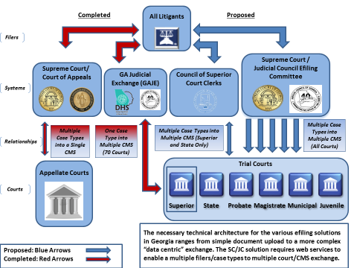
Graphic from February 2013.
Leveraging the existing systems in place throughout the State at the appellate levels or the Administrative Office of the Courts’ Child Support solution was considered but costs and complexity in supporting a solution led to inactivity. These existing solutions had defined customers in place that were generating the file packages and the receiving entities were a controlled environment where consistent processes could be implemented. These solutions also had a defined governance model and sustainable funding. The newly proposed exchanges did not.

Comparable Systems in other Jurisdictions
Through committee specific efforts and ancillary involvement with national organizations, systems and architectures from other states were reviewed as possible options. The closest options that resembled Georgia were the implementations in Texas and California. Both non-unified jurisdictions encountered similar obstacles as Georgia but they were addressed through viable rules and participating entities.

Other Factors Considered

Standards
Any system of the scale being discussed is going to require additional integrations with additional vendors. The only way to maintain an operative and manageable deployment is to enforce a standards based solution that can allow for modular changes and updates. The committee adopted the Electronic Court Filing Standards (ECF) in 2014.

Governance
Probably the single largest hurdle encountered by this committee, governance was challenged due to the multiple customer groups wanting efiling based on their specific requirements. Without statewide oversight and administration, the native governing bodies started their own efiling solutions and this service has become widespread throughout the State.

Odyssey http://www.odysseyefilega.com/

GSCCCA https://efile.gsccca.org/Home.aspx

SCED http://www.gasupreme.us/efile/

eFaST http://efast.gaappeals.us

GAJE http://w2.georgiacourts.gov/gaje/

PeachCourt http://www.greencourt.com/

ICON https://www.ez-filing.net

IronData http://www.irondata.com/public-sector/clerk-of-courts/solutions/e-filing

Costs
System development and maintenance has tangible costs that were never acquired through a legislative process. Existing resources were used in a consulting fashion but dedicated development time and resources were never allocated to create a system intended to be put into a production environment. This was mainly due to undefined costs structures for initial and future phases of an E-filing system.

Rules
The committee did convene several subcommittees that worked on various areas including the establishment of E-Filing specific rules. The subcommittee consisted of judges, clerks, attorneys and staff and a set rules that were adopted and incorporated into the Superior Court Uniform Rules.
http://www.gasupreme.us/wp-content/uploads/2015/02/UNIFORM-SUPERIOR-COURT-RULES_Updated_12_10_15_.pdf
Rule 36.16. Electronic Filing

Scope
There are many facets related to a fully functional E-Filing System and the committee covered all of these in some form. The physical process of filing documents electronically is expansive and therefore the committee chose to truncate the approach.
For the purposes of displaying a conceptual diagram in this report, overall functionality is being presented in the following graphic from California.
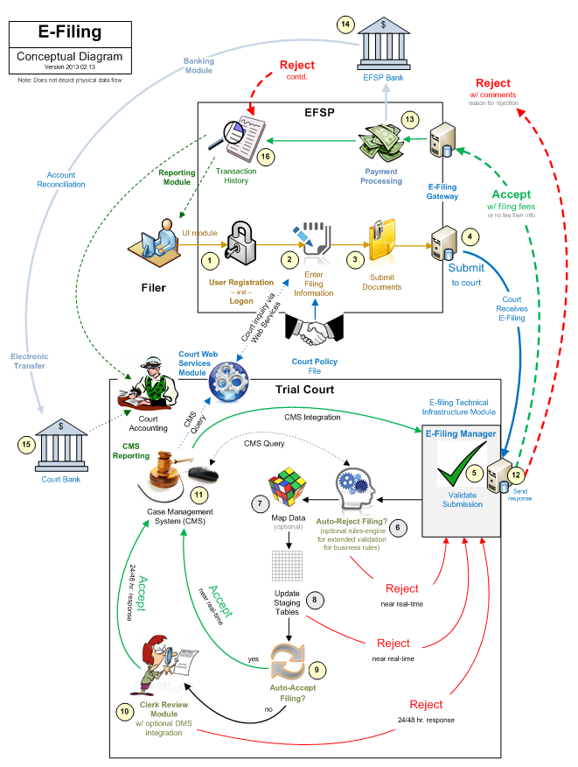
Reference: Electronic Filing Roadmap, An e-Filing guide for CA Trial Courts for Civil Case Types.
By: CA Judicial Council Technology Committee e-Filing Workstream – 3/1/2013

Functional Scope
The Portal concept, as it is being defined today, was first introduced by the Statewide Judiciary Civil E-Filing Steering Committee in 2013. After Tyler and GreenCourt both stood up E-Filing Managers (EFMs) for their respective customers, it was proposed that the committee get “out of the efiling business and reuse the current filing assemblies that already exist”. This was done through a revision of the E-Filing Position Paper and reviewed with the Chair and Co-Chair of the committee.
The Portal itself should simply be a front end entry point that satisfies the State Bar’s wish for a single login page. It is suggested that the committee mimic the PACER site which, for efiling, allows access to the US Supreme Court, the US Court of Appeals, National Courts and all District and Bankruptcy courts. PACER also allows for search case information through a Case Locator or by searching individual court websites. As proposed, the Portal would do little more than allow a user to register, and login to the main interface where they could then select what they wanted to do and search for basic location services for files.

For Filing:
Enter where you are filing: Select County
Enter what you are filing: Select Case Type

For Case Search:
Enter Party Name
Enter Case ID

This is enough information to find the vendor that offers the appropriate EFSP for participating courts. The first EFSPs would be the ones that already exist and rules for adding additional vendors, and services, would be defined. The idea here is to get this off the ground as soon as possible and leverage those vendors that already offer efiling. There would be instant production value because the full process would already exists to get the filing to the clerk, submit into the CMS and return the required subsequent information for completing the filing.

Advantages:
- Minimal new (initial) development for the vendors and the courts.
- Immediate use with existing EFSPs being employed.
- Higher adoption because processes and programs would be unchanged.
- Meets State Bar requirements for filing initiation.
- Vendors would manage all support, maintenance and versioning.
- Flow of data would be more straight-line versus multi-vendor MDEs.
Disadvantages:
- Difficult to enforce standards since vendors would control entire filing.
- Initial Portal would only offer vendor specific reporting.
  - If you file into two different EFSPs, there would be no link to display all filings.
- Little initial added-value at the Portal in Phase 1.

The Portal would be the entry point to access all the EFSPs and therefore would reside on top of the efiling lifecycle. The functions to be defined are the communication points and data elements that need to be shared between the portal and the EFSPs.

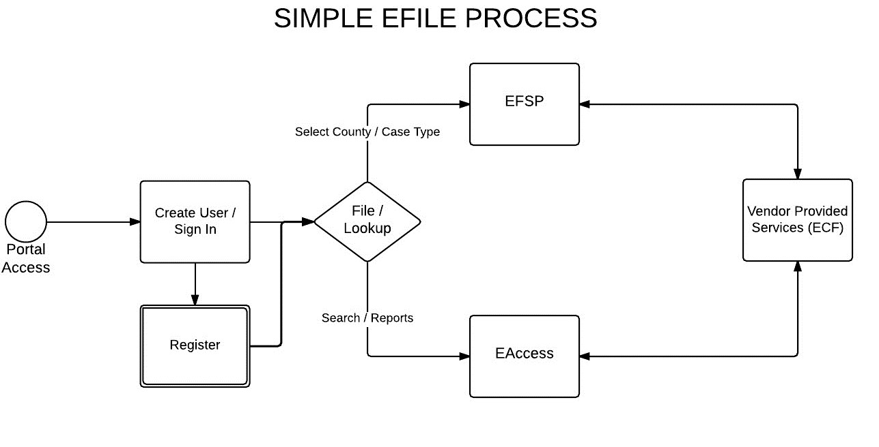

‘Where’ do we want our Customers to go?

Website

The starting point of the Portal will need to be a website that can be easily found and readily accessed by any browser. To serve as a viable starting point, the website will have to provide functionality, information or services that add value to people coming to the site. Phase one should start as not much more than a directory of services offered in the State with some level of guidelines to accessing those services.

Recommendations:
- .GOV – the consensus of the group is that the Top Level Domain (TLD) be a “.gov” to increase credibility and differentiate the site from potential commercial copycats. It has also been suggested that relative TLDs (.com, .org, .edu, etc…) be purchased to mitigate future pirating.

- Name – the committee realized that this Portal should take into account future expansion of services beyond efiling and therefore the Portal name should not be limited to a specific function. “Georgia’s Judicial Services Portal” has been utilized but a final recommendation has not be stated as of the time of this report.

- Look and feel – this area will be defined over time and follow the path of the explicit services added. It has been proposed that the interface be a simple, navigate-able site that allows for general sections to be grouped on a single page.

- Vendor Neutral Location – there is an objective to promote and maintain an independent site that allows for continuous benefits and opportunities. This can only be attained by having the site managed by a ‘State Agency’ such as the Administrative Office of the Courts or the State Bar.

‘Why’ are our Customers here?
Once the “Landing Page” has been located, there will be limited time and real estate for the purpose of the page to be made known. This function is essential to let visitors understand why this page is in place and why they should intend to continue and revisit. Other State’s such as Indiana (https://secure.in.gov/apps/courts/portal/) and Texas (http://www.texascourthelp.org/) were reviewed and further analysis on additional pages is being performed.

Recommendations:
- Portal “feel” – since the site’s primary object is to serve as a directory, the intent will be to keep the navigation “click-friendly” using blocks, tables or sections that are easily differentiated. Simple icons that provide a service will facilitate the customer experience.

- FAQs / Contact Us – visitors should be able to easily have questions answered and understand the intent of the Portal. Every effort to eliminate confusion or ambiguity of the site should be taken.

- “Coming Soon” – the committee has expressed an aversion to using language indicating that features are to be added. Notes or icons stating “coming soon”, “under construction” or “future features” will be avoided.

‘Who’ is accessing the Portal?
Now that the customer knows they are in the right place and they are ready to access one of the services offered, we need to know who this person is to better serve their needs. The identity management for customers will be crucial to ensure that the Portal is providing value. The State Bar and the NCSC Report both stated that simply posting links would not provide sufficient value to demonstrate the need for this Portal. Being able to uniquely identify customers is crucial to being able to allow them to interact with the Portal functions.

Recommendations:
- Profiles – some set of information needs to be collected for a practical profile to exist. The committee considered a “Registration” process but quickly sought alternative methods for collecting the information such as having customers reuse profile from other logins.

- Single Sign On (SSO) – this feature is a must-have according to all stakeholders. The ability to access multiple EFSPs as well as additional services will be a make or break feature. Without a workable SSO solution, customers will find little value in the Portal and even less reason to return.

- Payment Information – the Portal never intended to process payments or perform any type of financial transactions but the committee discussed potentially maintaining payment information as part of the profile. This would enable a single location to update credit card information that could be passed along to the appropriate service providers. This requirement needs further clarification.

‘What’ does our Customer want to do?
The basis for the Portal is efiling and the initial functions are related to the services in this area. All committee members are open to the discussions regarding expanded services and there are functions already being introduced beyond the scope of efiling but this report will focus on the areas specifically assigned to the subcommittee for review.
Recommendations:

Manage Profile
Each customer will need to have ultimate access to update profile information as needed. Following best practices and established processes for updating personal information should be implemented into the Portal.
A discussion with other vendors should be had to streamline the process with creating new and updating profiles. If profile information can be shared to reduce the need for redundant data entry and process, t should be implemented.

E-File
The customer will be able to provide minimal criteria in order to direct them to the appropriate EFSPs. Once the applicable vendor is identified, all tasks and functions, as provided by underlying vendors, both public and private, will be made available to the customer. The actual functions for efiling (document assembly, payments, etc…) will be performed by the EFSP.

E-Access
Accessing courts documents from various Case Management Systems has always been a difficult area to analyze. The technological and procedural aspects are simple as it’s no more than a retrieval function. However, the fact that there are multiple source systems and multiple rules for acquiring documents, the overall concept becomes onerous. The subcommittee has outlined a “Global Search” methodology where the customer can be made aware of documents and/or cases but the acquisition would require additional steps. A federated query model has been reviewed with vendors and the concept is being well received. Further requirements would involve vendor definitions and clerk approvals.

‘How’ does our Customer perform their tasks?
Finally, the customers have to actually be “handed off” to the correct vendor in order to proceed with their desired task. Some basic functions will remain in the portal but others will require a seamless method to allow customers to access additional function not available within the Portal. This will also allow for vendor specific functionality that requires additional authentication or customer specific information.
Recommendations:

Routing
Using Single Sign On tools will allow for the underlying vendor to know who is requesting services. Once that is determined the Portal will route the customers to the appropriate solution/vendor to accomplish if the service is not contained within the Portal.
Final Recommendation:
Keeping in mind that the underlying premise of the Portal is to direct customers to the services they need should always remain the primary consideration. Georgia already has services throughout the State that serve the disparate consumers of judicial services and the committee should not attempt to recreate or duplicate these services unnecessarily.

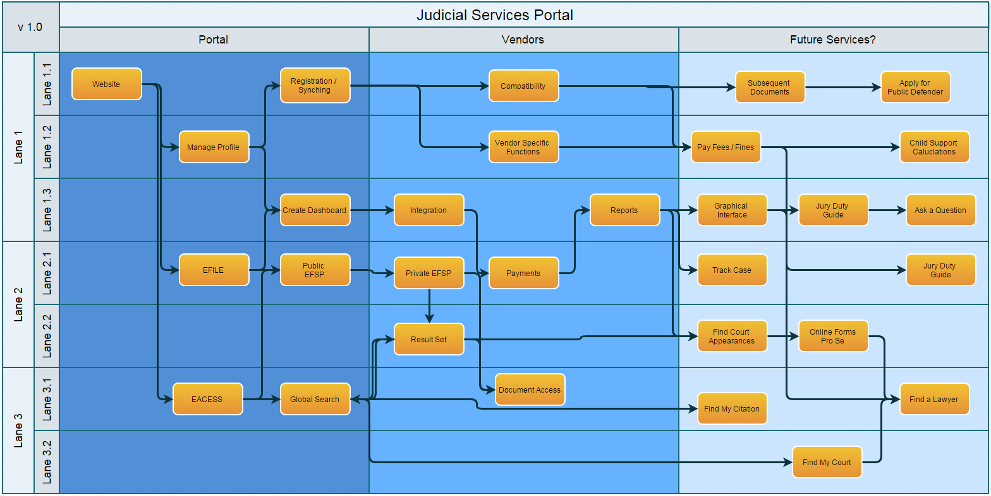
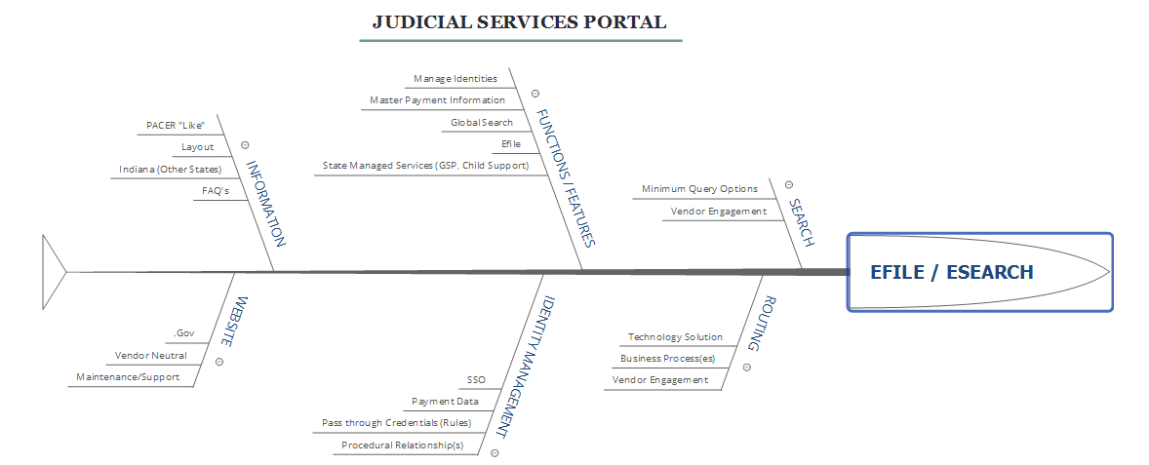

Appendix

State Bar Resolution

NCSC Report

