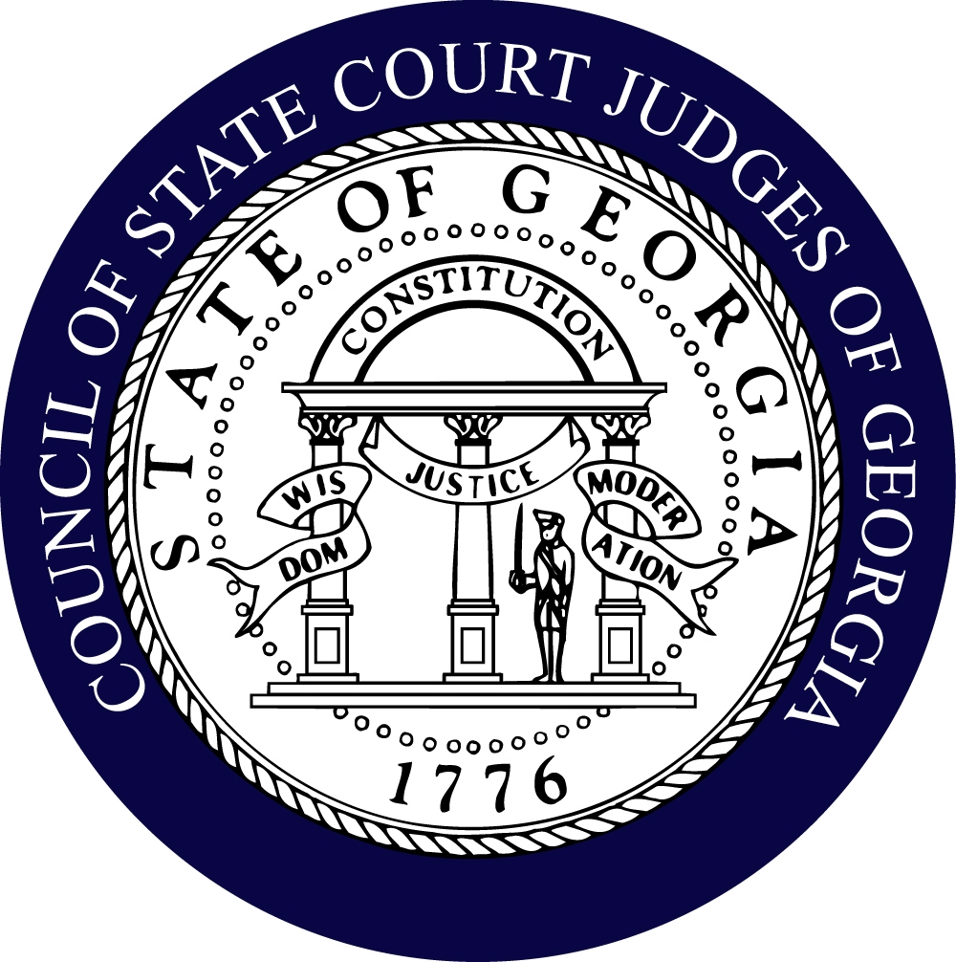

Council of State Court Judges of Georgia

“Impartial Courts – Judicial Excellence – Accessible and Efficient Justice”

244 Washington Street Telephone 404-651-6204
Suite 300 Facsimile 404-463-5173
Atlanta, GA 30334 E-Mail Bob.Bray@georgiacourts.gov

2022-2023 COMMITTEE ASSIGNMENTS
(as of July 1, 2022)

EXECUTIVE

President R. Violet Bennett (Wayne)
President Elect John K. Edwards, Jr. (Lowndes)
Secretary: Jeffrey. B. Hanson (Bibb)
Treasurer: Greg V. Sapp (Chatham)
Past President: Alvin T. Wong (DeKalb)
District 1: Billy Tomlinson (Bryan)
District 2: Shawn Rowland (Jeff Davis)
District 3: Ellen S. Golden (Lowndes)
District 4: Tammi L. Hayward (Clayton)
District 5: Monique Walker (Richmond)
District 6: John G. Breakfield (Hall)
District 7: Eric A. Richardson (Fulton)
District 8: Allison B. Salter (Cobb)

BENCH/CHARGE BOOK
Chair: Susan Edlein (Fulton)
Vice-Chair Wes Tailor (Fulton)

- Kimberly Anderson (DeKalb)
- Jason Ashford (Houston)
- Steve Campbell (Habersham)
- Maria Golick (Cobb)
- Jeff Hanson (Macon/Bibb)
- Wayne Purdom (DeKalb)
- Jay Roth (Fulton)
- John Stephenson (Dougherty)
- Ben Studdard (Sr. Henry)
- Josh Thacker (Spalding)
- Erica Tisinger (Carroll)

BUDGET
Chair: Maria Golick (Cobb)
Vice-Chair: Billy Mullinax (Walker)

- Vi Bennett (Wayne)
- John Edwards (Lowndes)
- Greg Fowler (Sr. Chatham)
- Ellen Golden (Lowndes) – JRS Rep
- Jeff Hanson (Bibb) - Treasurer
- Russ McClelland (Forsyth)
- Wes Tailor (Fulton)
- Al Wong (DeKalb)

CASE COUNTING STANDARDS
Chair: Michelle Helhoski (Cherokee)
Vice-Chair: Jane Morrison (Fulton)*

- Kimberly Alexander (DeKalb)*
- Robert Alexander (Jackson)*
- Jason Ashford (Houston)*
- Larry Baldwin (Hall)
- Vi Bennett (Wayne)*
- Eric Brewton (Cobb)*
- Ronda Colvin-Leary (Gwinnett)*
- Clarence Cuthpert (Rockdale)*
- Sharell Lewis (Bibb)*
- Russ McClelland (Forsyth)
- Bill Mills (Early)
- Greg Sapp (Chatham)*
- Jason Thompson (Fayette)

*Needs Assessment members

CONFERENCE VENUE SITE COMMITTEE
Chairs: John Holland (Turner)
Vice-Chair (Vacant)

- Leslie Abernathy-Maddox (Forsyth)
- Charles Auslander (Clarke)
- Carla Brown (Gwinnett)
- Jason Fincher (Cobb)
- Janis Gordon (Sr. DeKalb)
- Steve Jenkins (Elbert)
- Marsha Lake (Cobb)
- Donny Peppers (Sr. Walker)
- Allison Salter (Cobb)
- Greg Sapp (Chatham)
- Margaret Spencer (Clayton)
- Doug Ashworth ((ICJE)

COUNCIL HISTORY COMMITTEE
Chair: Ron Ginsberg (Sr. Chatham)

- Melodie Clayton (Sr. Cobb)
- Howard Cook (Sr. Gwinnett)
- Jack McLaughlin (Sr. DeKalb)

DUI/DRUG COURT COMMITTEE
Co-Chairs: Eddie Barker (Douglas) and Jason Thompson (Fayette)
Recording Secretary: TBD

- Kimberly Anderson (DeKalb)
- Jason Ashford (Houston)
- Charles Auslander (Clarke)
- Larry Baldwin (Hall)
- Pattie Booker (Sr. Richmond)
- Emily Brantley (Gwinnett)
- Shawn Bratton (Gwinnett)
- Leon Braun (Sr. Liberty)
- Eric Brewton (Cobb)
- Bridgette Campbell (Cobb)
- Melodie Clayton (Sr. Cobb)
- John Dennis (Chattooga)
- Susan Edlein (Fulton)
- Brian Fortner (Douglas)
- Greg Fowler (Sr. Chatham)
- Ellen Golden (Lowndes)
- Jeff Hanson (Bibb)
- Michelle Helhoski (Cherokee)
- Steve Jenkins (Elbert)
- Alan Jordan (Cherokee)
- Wesley Leonard (Troup)
- Sharell Lewis (Bibb)
- Vincent Lotti (Henry)
- Russ McClelland (Forsyth)
- Kellie McIntyre (Richmond)
- Ana Maria Martinez (DeKalb)
- Dee Morris (Cherokee)
- Jeffery Osteen (Liberty)
- Seay VanPatten Poulakos (Coweta)
- Ralph Powell (Worth)
- Greg Sapp (Chatham)
- Margaret Spencer (Clayton)
- Kiesha Storey (DeKalb)
- Wes Tailor (Fulton)
- Erica Tisinger (Carroll)
- David Watkins (Richmond)
- Derek White (Chatham)
- Al Wong (DeKalb)

EDUCATIONAL PROGRAMS
Co-Chairs: Leslie Abernathy-Maddox (Forsyth) and
Allison Salter (Cobb)

- Kimberly Alexander (DeKalb)
- Kimberly Anderson (DeKalb)
- Jason Ashford (Houston)
- Diane Bessen (Fulton)
- Eric Brewton (Cobb)
- Bridgette Campbell (Cobb)
- John Carbo (Sr. Clayton)
- Ronda Colvin-Leary (Gwinnett)
- John Edwards (Lowndes)
- Janis Gordon (Sr. DeKalb)
- Jason Harper (Sr. Henry)
- Michelle Helhoski (Cherokee)
- Alan Jordan (Cherokee)
- Marsha Lake (Cobb)
- Sharell Lewis (Bibb)
- Jeannette Little (Sr. Troup)
- Bob Mock (Sr. Gwinnett)
- Shalonda Jones-Parker (Clayton)
- Wayne Purdom (DeKalb)
- Margaret Spencer (Clayton)
- Pam South (Gwinnett)
- Kiesha Storey (DeKalb)
- Ben Studdard (Sr. Henry)
- Lynne Moore Nelson (ICJE)

LEGISLATIVE
Co-Chairs: Maria Golick (Cobb) and Ron Ramsey (DeKalb)

- Jason Ashford (Houston)
- Larry Baldwin (Hall)
- Vi Bennett (Wayne)
- Diane Bessen (Fulton)
- John Breakfield (Hall)
- Patricia Booker (Sr. Richmond)
- Leon Braun (Sr. Liberty)
- Carla Brown (Gwinnett)
- Steve Campbell (Habersham)
- John Carbo (Sr. Clayton)
- Jack Carney (Sr. Bryan)
- Ronda Colvin-Leary (Gwinnett)
- Neal Dettmering (Sr. Douglas)
- Susan Edlein (Fulton)
- John Edwards (Lowndes)
- Susan Forsling (Sr. Fulton)
- Brian Fortner (Douglas)
- Robert Garner (Barrow)
- Ron Ginsberg (Sr. Chatham)
- C. J. Gober (Sr. Cherokee)
- Ellen Golden (Lowndes)
- Jason Harper (Sr. Henry)
- John Holland (Turner)
- Joseph Iannazzone (Sr. Gwinnett)
- Mike Jacobs (DeKalb)
- Alan Jordan (Cherokee)
- Jeannette Little (Sr. Troup)
- Russ McClelland (Forsyth)
- Jane Manning (Cobb)
- Jeffery Osteen (Liberty)
- Wayne Purdom (DeKalb)
- Eric Richardson (Fulton)
- Jay Roth (Fulton)
- Greg Sapp (Chatham)
- Richard Slaby (Richmond)
- Margaret Spencer (Clayton)
- Ben Studdard (Sr. Henry)
- Wes Tailor (Fulton)
- Erica Tisinger (Carroll)
- Billy Tomlinson (Bryan)
- Al Wong (DeKalb)
- Charlie Wynne (Sr. Hall)

MANDATORY CJE
Chair: Eric Brewton (Cobb)
Vice-Chair: Billy Mullinax (Walker)

- John Edwards (Lowndes)
- Bob Mock (Sr. Gwinnett)
- Alan Thrower (Baldwin)
- Rick Waters (Mitchell)
- Lynne Moore Nelson (ICJE)

MISDEMEANOR MENTAL HEALTH
Chair: Patsy Porter (Fulton)

- Eric Brewton (Cobb)
- Maria Golick (Cobb)
- Ellen Golden (Lowndes)
- Michelle Helhoski (Cherokee)
- Pam South (Gwinnett)
- John Stephenson (Dougherty)

NEW JUDGE EDUCATION AND MENTORING
Chair: Susan Edlein (Fulton)
Recording Secretary: Allison Salter (Cobb)

- Charles Auslander (Clarke)
- Eddie Barker (Douglas)
- Eric Brewton (Cobb)
- Carla Brown (Gwinnett)
- Melodie Clayton (Sr. Cobb)
- Ronda Colvin-Leary (Gwinnett)
- John Edwards (Lowndes)
- Ellen Golden (Lowndes)
- Janis Gordon (Sr. DeKalb)
- Jeff Hanson (Macon/Bibb)
- Tammi Hayward (Clayton)
- Steve Jenkins (Elbert)
- Kellie McIntyre (Richmond)
- Shalonda Jones-Parker (Clayton)
- Seay Poulakos (Coweta)
- Ben Richardson (Muscogee)
- Josh Thacker (Spalding)
- Jason Thompson (Fayette)
- Alan Thrower (Baldwin)
- Monique Walker (Richmond)
- Al Wong (DeKalb)
- Lynne Moore Nelson (ICJE)

NOMINATING
Chair: Russ McClelland (Forsyth)

- Greg Fowler (Sr. Chatham)
- Marica Golick (Cobb)
- Tammi Hayward (Clayton)
- Steve Jenkins (Elbert)
- Wayne Purdom (DeKalb)
- Wes Tailor (Fulton)
- Al Wong (DeKalb)

PART-TIME JUDGES
Chair: James Garner (Treutlen)
Vice-Chair: Ralph Powell (Worth)

- Vi Bennett (Wayne)
- Robert Gardner (Barrow)
- Ron Hallman (Evans)
- Hugh McCullough (Tattnall)
- Hubert Reeves (Jenkins)
- Alan Thrower (Baldwin)
- Billy Tomlinson (Bryan)

PERSONNEL COMMITTEE

Chair: David Darden (Sr. Cobb)

- Greg Fowler (Chatham)
- Ron Ginsberg (Sr. Chatham)
- Russ McClelland (Forsyth)
- Wes Tailor

PROBATION
Chair: Ralph Powell (Worth)
Vice-Chair: Jeff Hanson (Bibb)

- Leslie Abernathy-Maddox (Forsyth)
- Larry Baldwin (Hall)
- Eddie Barker (Douglas)
- Pattie Booker (Richmond)
- Carla Brown (Gwinnett)
- John Cranford (Coweta)
- John Dennis (Chattooga)
- John Edwards (Lowndes)
- Richard Kent (Colquitt)
- Sharell Lewis (Bibb)
- Russ McClelland (Forsyth)
- Hugh McCullough (Tattnall)
- Bob Mock (Sr. Gwinnett)
- Billy Mullinax (Walker)
- Ben Studdard (Sr. Henry)
- Rick Waters (Mitchell)
- David Watkins (Richmond)

RESOLUTIONS AND AWARDS
Chair: Jean Bolin (McIntosh)

- Linda Cowen (Clayton)
- Greg Fowler (Chatham)
- Janis Gordon (Sr. DeKalb)
- Jeannette Little (Troup)
- Toby Prodgers (Cobb)

RETIREMENT
Chair: Alan Jordan (Cherokee)
Vice-Chair: Ellen Golden (Lowndes)

- Pattie Booker (Richmond)
- John Edwards (Lowndes)
- James Irvin (Stephens)
- Marsha Lake (Cobb)
- John Stephenson (Dougherty)

SENIOR JUDGE/JUDGE EMERITUS COMMITTEE
Co-Chairs: David Darden (Sr. Cobb

- Greg Fowler (Sr. Chatham)
- Jeannette Little (Sr. Troup)
- Bob Mock (Sr. Gwinnett)
- Kelly Turner (Sr. Lowndes)

STATEWIDE PLANNING
Chair: Ben Studdard (Sr. Henry)
Vice-Chair: Vacant

- Jason Ashford (Houston)
- Leon Braun (Sr. Liberty)
- Jack Carney (Sr. Bryan)
- Melodie Clayton (Sr. Cobb)
- Richard Kent (Colquitt)
- Billy Mullinax (Walker)
- Monique Walker (Richmond)

STRATEGIC PLANNING
Co-Chairs: Jeff Hanson (Bibb) and John Edwards (Lowndes)

- Kimberly Anderson (DeKalb)
- Jason Ashford (Houston)
- Eddie Barker (Douglas)
- Vi Bennett (Wayne)
- Diane Bessen (Fulton)
- John Breakfield (Hall)
- Eric Brewton (Cobb)
- Melodie Clayton (Sr. Cobb)
- Ronda Colvin-Leary (Gwinnett)
- David Darden (Sr. Cobb)
- Susan Edlein (Fulton)
- Greg Fowler (Sr. Chatham)
- Michael Gailey (Putnam)
- Ellen Golden (Lowndes)
- Maria Golick (Cobb)
- Tammi Hayward (Clayton)
- James Irvin (Stephens)
- Jeannette Little (Sr. Troup)
- Russ McClelland (Forsyth)
- John Murphy III (Jefferson)
- Wayne Purdom (DeKalb)
- Ron Ramsey (DeKalb)
- Eric Richardson (Fulton)
- Shawn Rowland (Jeff Davis)
- Allison Salter (Cobb)
- Greg Sapp (Chatham)
- Danny Shepard (Miller)
- Pam South (Gwinnett)
- Margaret Spencer (Clayton)
- Ben Studdard (Sr. Henry)
- Wes Tailor (Fulton)
- Josh Thacker (Spalding)
- Erica Tisinger (Carroll)
- Billy Tomlinson (Bryan)
- Monique Walker (Richmond)
- Al Wong (DeKalb)

TECHNOLOGY
Chair: Jason Ashford (Houston)
Vice-Chair: Diane Bessen (Fulton)

- Harold Benefield Sr. Clayton)
- Pattie Booker (Richmond)
- John Dennis (Chattooga)
- Neal Dettmering (Sr. Douglas)
- John Edwards (Lowndes)
- Jason Fincher (Cobb)
- Joe Iannazzone (Sr. Gwinnett)
- Marsha Lake (Cobb)
- Sharell Lewis (Bibb)
- Russ McClelland (Forsyth)
- Ben Studdard (Sr. Henry)
- Wes Tailor (Fulton)
- Monique Walker (Richmond)

UNIFORM COURT RULES
Chair, Greg Sapp (Chatham)
Vice Chair: TBD

- Leslie Abernathy-Maddox (Forsyth)
- Larry Baldwin (Hall)
- Melodie Clayton (Sr. Cobb)
- Greg Fowler (Chatham)
- Joe Iannazzone (Gwinnett)
- James Irvin (Stephens)
- Russ McClelland (Forsyth)
- Wayne Purdom (DeKalb)
- John Stephenson (Dougherty)
- Wes Tailor (Fulton)

Special Appointments to Other Committees:

Institute of Continuing Judicial Education Board (ICJE)
Allison Salter (Cobb) 2 year 6/30/23

Judicial Council Records Retention Committee
Kiesha Storey (DeKalb)
Jeannette Little (Troup)

Judicial Council Committee on Victims of Domestic Violence
Maria Golick (Cobb)
Jeannette Little (Troup)

State Commission on Family Violence
Leslie Abernathy (Forsyth) Governor Appointment August 2018

Advisory Council of Board to
Department of Community Supervision
Ralph Powell (Worth)

Judicial Council Committee on Public Service Announcements - COVID
Ben Richardson Muscogee)

Judicial Council Technology Committee
Diane Bessen (Fulton) June 30, 2018

Judicial Council Committee on Cyber Insurance Implementation
Diane Bessen (Fulton)

Judicial Council Committee on Grants
Eric Richardson (Fulton) June 30, 2021

Judicial Council Committee on Interpreters
Jean Bolin (McIntosh) June 30, 2023

Supreme Court – Board to Determine Fitness of Bar Applicants
Janis Gordon (Sr. DeKalb)

Judicial Council Committee on Emergency Preparedness and Continuity of Court Operations
Eric Brewton (Cobb)
Bob Bray – Advisory Member

Pre-Trial Justice in Georgia
Wes Tailor (Fulton)

Judicial Council Legislative Committee
Al Wong (DeKalb)
Maria Golick (Cobb)
Ron Ramsey (DeKalb)
Bob Bray (Advisory)

Council of Accountability Courts
Charles E. Auslander, III (Clarke) – Vice-Chair
Jason Thompson (Fayette) – Exec. Committee
Margaret Spencer (Clayton) – Advisory Member

Georgia Commission on Dispute Resolution
Charles E. Auslander, III (Clarke)

Judicial Council Committee on Access to Justice
Jason Thompson (Fayette)
Linda Cowen (Clayton)
Jane Morrison (Fulton)

Chief Justice’s Commission on Professionalism
Russ McClelland - 6/30/2024

Judicial Council Committee on Improving Access to Legal Resources
Jason Ashford (Houston)

Judicial Qualifications Commission
Vacant – 7/1/2017 - 6/30/2021

Judicial Council COVID-19 Task Force
Russ McClelland (Forsyth)

Judicial Council COVID-19 Task Force Jury Public Service Announcements Subcommittee
Ben Richardson (Muscogee)

Georgia Board of Court Reporting
John Edwards (Lowndes)

Judicial Council Subcommittee on Public Service Announcements for Juries
Ben Richardson (Muscogee)

Digital Court Reporting Rules Subcommittee
Jane Morrison – Chair (Fulton)

Ad Hoc Committee on Judicial Emergency Preparedness
TBD

Georgia Judicial Retirement System – Board of Trustees (Governor Appointment – 4 Year Term)
Ellen Golden (Lowndes) – 7/1/2020

Subcommittee – Judicial Council Legislative
Committee: Study of Certiorari Procedures
Judge Carla E. Brown (Gwinnett) Ad Hoc 2016

Judicial Council Workload Assessment
Committee
Michelle Helhoski (Cherokee)

Judicial Council Budget Committee
Al Wong (DeKalb)
Maria Golick (Cobb)

Judicial Council Automated Data Collection Subcommittee
Jeff Hanson (Bibb)

Bench & Bar Committee of State Bar
Jane Manning (Cobb)

Judge Wong has worked very hard on this listing and tried to put everyone who indicated an interest in being on the committee that he or she requested. If he has left someone off, it was not intentional, and he or she will be added to a committee upon request

*New judges

